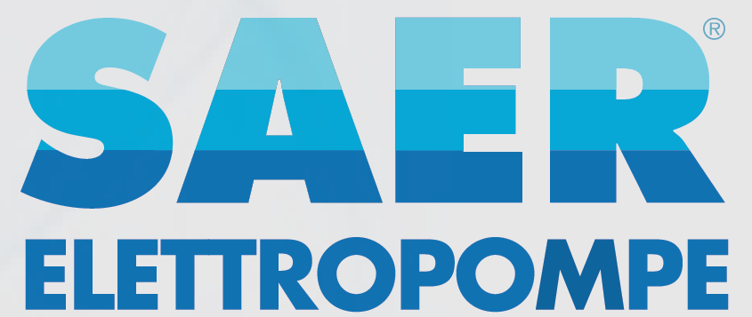
SAER Elettropompe S.p.A. | The High-Quality Italian Pumps Brand
IN-LINE ELECTRIC PUMPS
Whether you are looking for a quiet solution or resistance to high temperature for your HVAC applications,
SAER’s new L series is the answer. An in line pump, characterized by innovative compact design
to save space, combined with special nodular engineering cast iron construction which ensures
constant performance over time even under harsh conditions. Made in Italy. Quality guaranteed.
The range starts from 0,18kW up to 92kW, Suction & outlet from DN25 up to DN150 and a flow rate
from 0,5 up to 800m3/h.

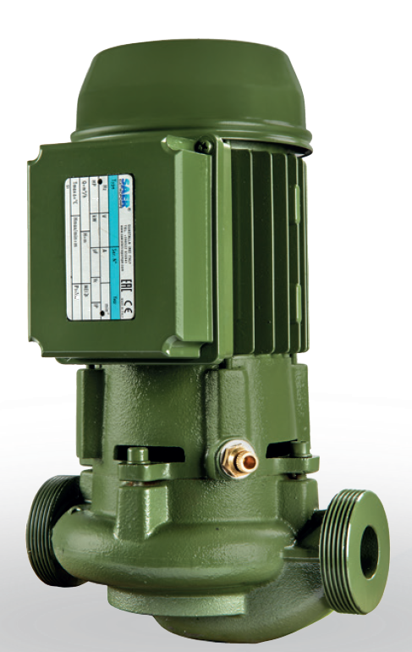

IR - END SUCTION CLOSE COUPLED CENTRIFUGAL PUMPS
NEW 2 & 4 POLES MODELS FOR POWER UP TO 90kW
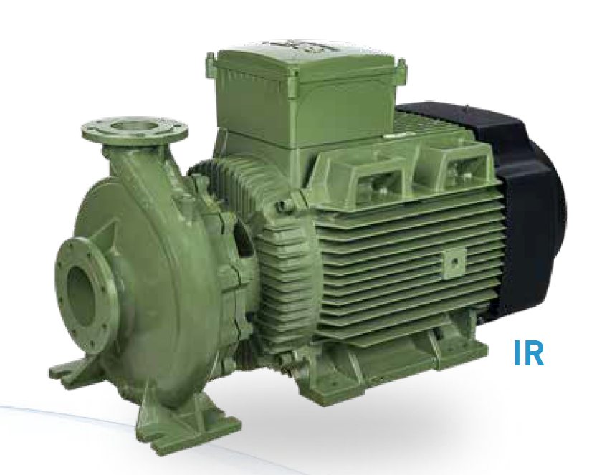
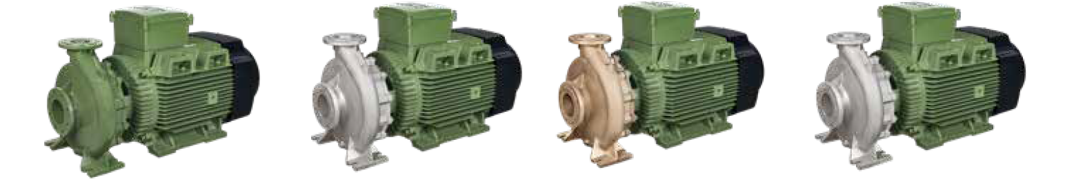

Multistage close-coupled vertical electric
pumps, not self-priming, of minimum dimension
suitable for lifting plants with or without autoclave,
irrigation system and all other applications
where high pressure is required.
MKM: complete electric pump.
Pumps and motors in conformity with
2009/125/CE Directive (ErP).
PERFORMANCE DATA
37 models divided in 4 series, with powers from
0,75 up to 4 kW.
Performances at ~2900 rpm.
Max Flow: 13 m3/h.
Max head:123,5m (136,5m Q=0).
Temperature of the pumped liquid: min -15°C max +90°C (on request 120°C).
Max working pressure (maximum admitted pressure considering the sum of the maximum
suction pressure and head at shut of):
Type Water
Temperature -15°C ÷ +90°C 25 Max
Counterclockwise rotation, viewed facing the motor

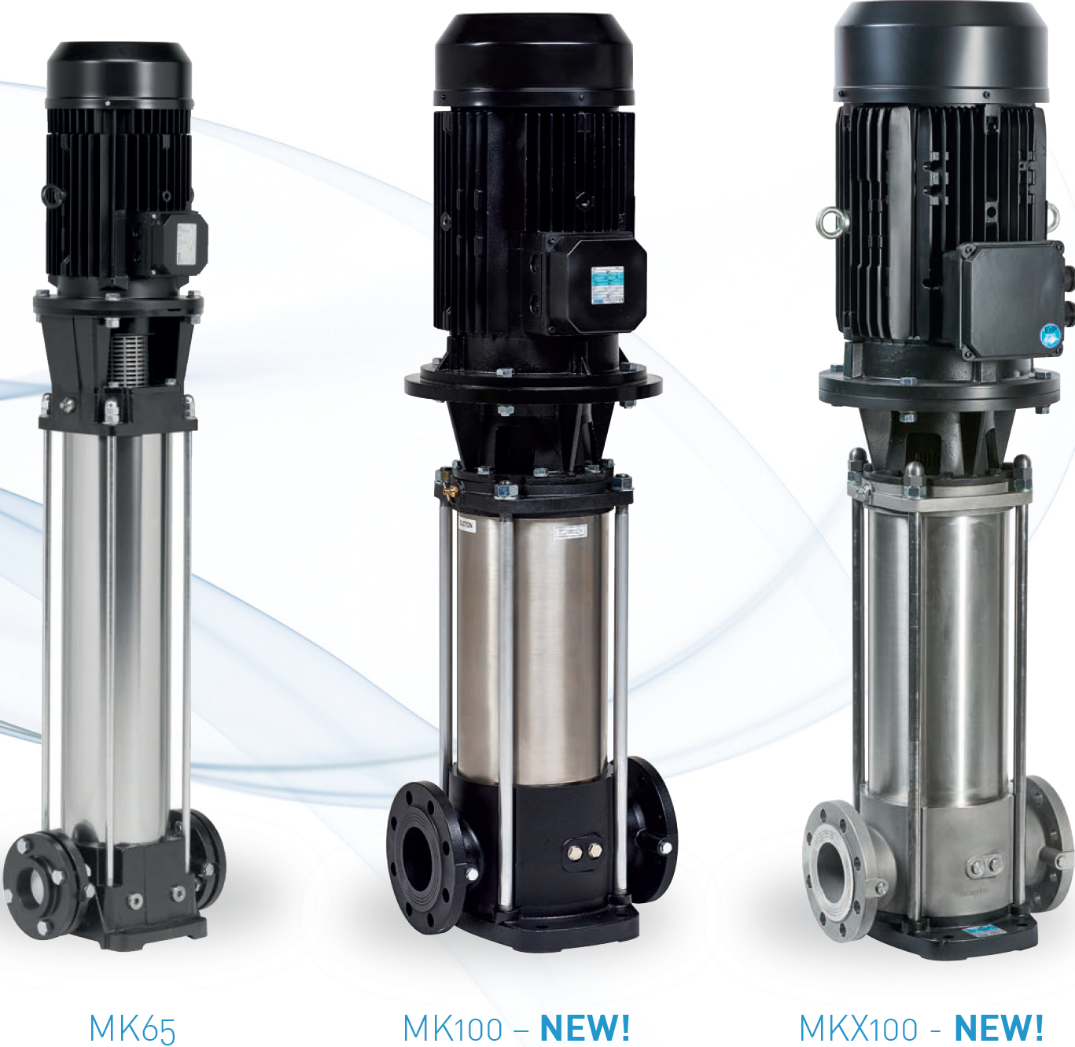

SAER produces and exports more than 700 types of submersible and centrifugal pumps and motors all over the world. End-suction
pumps, multistage horizontal or vertical pumps, split case pumps, in-line pumps, residential pumps, booster sets, electric motors,
submersible pumps and motors.
The products are available in different materials (cast iron, bronze, stainless steel, superduplex) and in a wide range of options.
SAER offers global solutions in the water field.

